About Us

The Flagler Crab Lab is a dynamic undergraduate research group based at Flagler College. Our goal is to provide hands-on research experiences to students in a variety of scientific disciplines, while also contributing to the advancement of knowledge in our field of study.

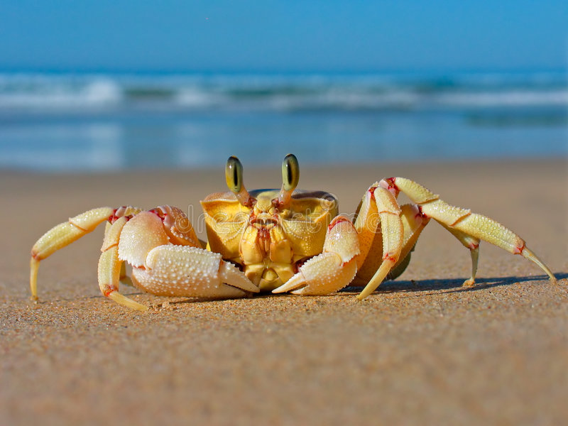Our focus is on the biology and ecology of crabs, and we conduct cutting-edge research on a variety of topics, including behavior, physiology, and conservation. Our lab is equipped with state-of-the-art equipment and our experienced staff provides mentorship and guidance to students at all levels of experience.

At The Flagler Crab Lab, we believe that undergraduate research is an essential part of a well-rounded education. Our students are fully involved in every aspect of the research process, from design to data analysis, and they develop valuable skills in critical thinking, problem-solving, and communication.

We are proud to be a part of Flagler College's commitment to providing students with exceptional learning opportunities, and we are committed to making a positive impact in our field of study. Whether you are a student looking to get involved in research or a professional looking to collaborate, we welcome you to join us at The Flagler Crab Lab.